TEVO TARANTULA PRO

**Specifications:**

| Build Volume | 235 x 235 x 250 mm (9.25 x 9.25 x 9.84 in.) |
| --- | --- |
| Layer Resolution Low | 350 microns |
| Layer Resolution High | 50 microns |
| Nozzle Diameter | 0.4 |
| Print Speed Min. | 60 mm/s |
| Print Speed Max. | 150 mm/s |

Material (Frames): Aluminum Extrusion

Nozzle temperature: 180 - 240 Degree Celsius

Layer thickness: 0.05-0.3mm

Memory card offline print: TF card

Platform temperature: 0 - 80 Degree Celsius

Supporting material: ABS,Flexible PLA,HIPS,PLA,Wood

Material diameter: 1.75mm

Model supporting function: Yes

XY-axis positioning accuracy: 0.05mm

Voltage: 110-240V

Voltage Range: AC 110V-240V, 50-60Hz, DC 24V, 8.5A

Connector Type: TF card,USB

Host computer software: Craftware,Cura,Simplify3D,Slic3r

**Assembly:**

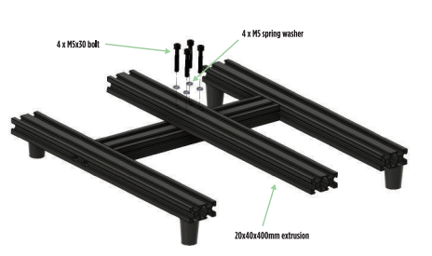 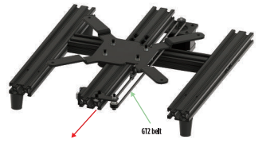

Bottom Frame Assembly extrusion frame and Bed carriage

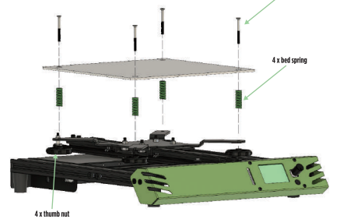 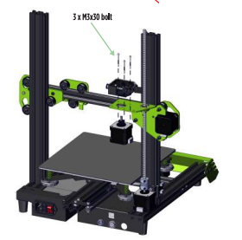

Controller, PSU and Front Panel 3D assembly

**Electronics:**

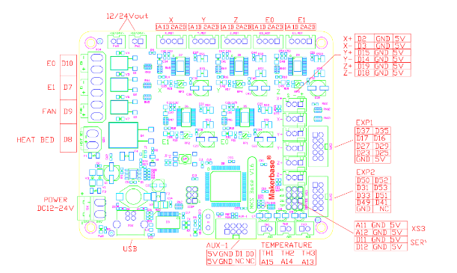

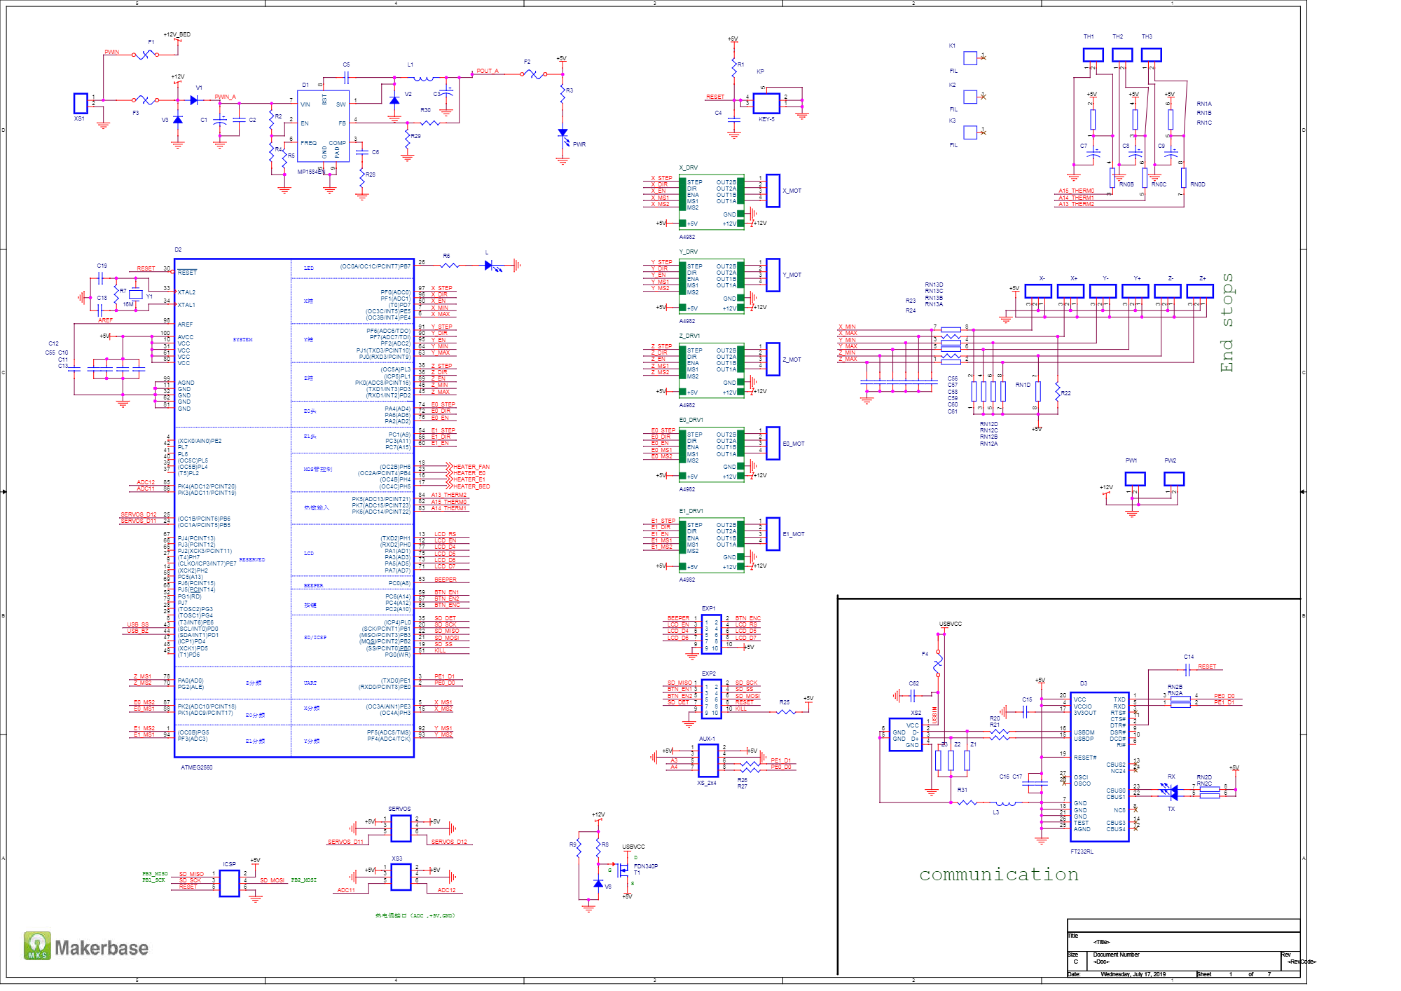

**Software:**

